COMP 354: INTRODUCTION TO SOFTWARE
ENGINEERING

PROJECT MANAGEMENT APPLICATION
TEST DESIGN DOCUMENTATION

Team B

Alex Huot
Dmitri Novikov
David Gurnsey
Jun Hui Chen
Philip Eloy
Robert Wolfstein
Nicholas Francoeur
Mehdi Jamal Mokhtar
Nivine Shebarou
Lee Kelly
Steven Di Lullo

Tuesday, August 26th , 2014

Revision History:

Date Created: Aug 17th, 2014

Most Recent Update: Aug 26th, 2014

Previous Updates:

Revision Date | Contributor | Summary
Aug 17th, 2014 | Alex | Created doc based on passed iteration template.
Aug 20th 2014 | Robert | Created outline, added function choices
Aug 21st, 2014 | Robert | Description of chosen functions
Aug 21st, 2014 | Nivine & Mehdi | Added CFGs and Input specifications
Aug 25th, 2014 | Alex | Added function headers, added discussion section text, revised
Aug 26th, 2014 | Several people | Spell-checking, flow-revision, general formatting

Table of Contents
Revision History: 2
Document Description: 5
Introduction: 5
A note on selected functions: 5
1.0 Choice of Functions, Justification and Input Ranges 5
2.0 White Box Testing 6
3.0 Black Box Testing 6
4.0 Test Implementation & Headers 6
5.0 Discussion 6
6.0 A Note on Redesign 6
1.0 Choice of Functions, Justification and Input Ranges 7
1.1 Choice of White-Box Functions 7
1.2 Choice of Black-Box Functions 12
2.0 White-Box Testing 17
2.1 Activity – areValidtimes() 18
2.2 MilestoneNode – equals() 22
2.3 NodeGraph – addEdge() 27
2.4 EarnedValue – calculateActualCost() 32
2.5 MilestoneNode – toStringArrows() 36
3.0 Black-Box Testing 41
3.1 EarnedValue - getActivityScheduleValue() 42
3.2 Project - areValidPercentages() 42
3.3 Project - areValideValues() 42
3.4 Activity - areValideValues() 43
3.5 Activity - areValidPercentAndCost() 43
4.0 Test Implementation & Headers 44
5.0 Discussion 45
6.0 A Note on Redesign 46
References: 47
Appendix 48
Appendix A – White-Box Function Headers 48
NodeGraph - addEdge() 48
EarnedValue - calculateActualCost() 49
MilestoneNode - equals() 50
MilestoneNode - toStringArrows() 52
MilestoneNode – equals() 54
Appendix B – Black-Box Function Headers 56
EarnedValue - getActivitySchedule() 56
Activity - areValidPercentAndCost() 56
Activity - areValidTimes() 56
Project - areValidPercentages() 57
Project - areValidValues() 57

List of Figures
Figure 1: areValidTimes() - Code 18
Figure 2: areValidTimes() - CFG 19
Figure 3: equals() - Code 22
Figure 4: equals() - CFG 23
Figure 5: addEdge() - Code 27
Figure 6: addEdge() - CFG 28
Figure 7: calculateActualCost() - Code 32
Figure 8: calculateActualCost() - CFG 33
Figure 9: toStringArrows() - Code 36
Figure 10: toStringArrows() - CFG 37

Document Description:

Introduction:
This document provides design documentation for Team B's third iteration deliverable. The chosen functions to test, justification for said choices, and all test-design is provided here. The test implementations are included in a separate package in the final source code submission.

A note on selected functions:
The requirements for this iteration's testing were to select 5 functions suitable for both white-box and black-box testing. Unfortunately, without important changes to the logic of our code, we had no such functions to test. In fact, several of our black-box functions are segments of code originally part of larger algorithms, which we extracted in the form of helper functions ideal for this type of test. Despite this, tests suitable for black-box had very simple decision logic, and those suitable for white-box seldom took more than 1 parameter with a specifiable range. For this reason, we opted to perform white-box and black-box tests on a different set of 5 functions for each (save for one function). We felt this would better demonstrate our understanding of these testing principles, and offer more interesting results for discussion.

1.0 Choice of Functions, Justification and Input Ranges
This section outlines the choice of our 5 black-box and 5 white-box functions. Here we also provide a short description of each function and the justification for our choices. The input ranges are specified for each.

2.0 White Box Testing
The Control Flow Graphs (CFGs), cyclomatic-complexity and basis-path coverage calculations for our white-box functions are provided here.

3.0 Black Box Testing
This section provides the wort-case boundary testing design for our black-box tests. As we are not performing any white-box tests for these functions, we opted to omit the CFGs and basis-path coverage calculations for these functions. The black-box tests are performed using the worst-case boundary value-analysis method.

4.0 Test Implementation & Headers
A brief description on how each test case was implemented, and the information contained in each header.

5.0 Discussion
The concluding discussion of insights gained from both test-design as well as implementation.

6.0 A Note on Redesign
Several changes needed to be made by the development team, as certain design decisions proved to be inappropriate after our second iteration. This sections briefly outlines these changes.

1.0 Choice of Functions, Justification and Input Ranges

1.1 Choice of White-Box Functions
The 5 selected functions for our white-box tests are:
- Class: Activity
public static boolean areValidTimes(double mostLikely, double optimistic,
double pessimistic)

Description:
Used by Activity's constructor, this function checks that the Activities’ projected times (mostLikely, optimistic, pessimistic) are within suitable ranges.

Justification:
This function is the only function we deemed acceptable for both white- and black-box testing. The justification for the black-box version is listed in section 1.2. This function is ideal for white-box as it entails a series of conditional checks to determine the validity of inputs. The importance of this function paired with its decision logic make it an ideal candidate for white-box tests.

- Class: MilestoneNode
public boolean equals(Object obj)

Description:
This is an override of the Object classes equals function, and tests the equality between 2 MilestoneNodes.

Justification:
Although this function is simple in theory, it is an important one to test, as it performs an important task with somewhat confusing decision logic.

Input Ranges:
This function takes an Object as input, and thus we can pass any object we like to ensure every basis-path is covered.

- Class: NodeGraph
public void addEdge(MilestoneNode v, MilestoneNode w)

Description:
This function adds an edge to the NodeGraph, connecting MilestoneNodes v and w.

Justification:
When building node graphs, there is a possibility that certain nodes have already been added. This coupled with the existence (or lack) of dependencies, we encounter a series of interesting conditions on which to base a white-box test.

Input Ranges:
This function depends on the state of the NodeGraph being built, as well as the relationship between both MilestoneNodes passed as inputs. These relationships can be manufactured manually in order to test all basis paths.

- Class: EarnedValue
public void calculateActualCost()

Description:
Calculates the actual cost for a Project based on all it's activities and their percentage of completion.

Justification:
The input of an Activity list are what make this function structurally ideal for white-box testing. Several potential paths, perfect for white-box.

Input Ranges:
Takes no parameters; all calculations are performed on the EarnedValue object's Project object and its Activities
- Class: MilestoneNode
public String toStringArrows(String type)

Description:
This function generates a string describing the MilestoneNode's related activities, namely those to complete by the milestone, or those available after the milestone.

Justification:
As with previous white-box tests, the decision logic entailed by this function make it an interesting candidate. It relies on both the type of arrows the caller wishes to consider, as well as the relationship between the MilestoneNode and other acitivities.

Input Ranges:
The function takes a type as input, and depending on this type and the MilestoneNode's local Activity list, a descriptive string will be generated.

1.2 Choice of Black-Box Functions
The 5 selected functions for our black-box tests are:
- Class: EarnedValue
public static double getActivityScheduleValue(double activityEarlyFinish,
double activityLateFinish, double activityPlannedVal,
double activityDuration, double daysSinceStart)

Description:
This function is important for calculating the scheduled value of an activity during an Earned Value Analysis procedure.

Justification:
By taking several numerical inputs with specifiable range, this function is an ideal candidate for worst-case boundary value analysis.

Input Ranges:

double activityEarlyFinish = [0, 731] // Days. Max set to 2 years

double activityLateFinish = [0, 731] // Days. Max set to 2 years

double activityPlannedVal = [0, 1000000] // $. Max set to 1 million

double activityDuration = [0, 731] // Days. Max set to 2 years

double daysSinceStart = [0, 73] // Days. Max set to 2 years less a day
- Class: Project
public static boolean areValidPercentages(double percentage1,
double percentage2)

Description:
This is a validity checking function for use in the constructor of Project, and verifies that the input percentages are valid. It is necessary to ensure data integrity and proper program functionality.

Justification:
This checks that the Project’s percentages are within suitable ranges, making it ideal for boundary-value analysis.

Input Ranges:

double percentage1 = [0, 1] // Percentage in decimal format
double percentage2 = [0, 1] // Percentage in decimal format
- Class: Project
public static boolean areValidValues(double budgetAtCompletion,
double actualCost, double earnedValue)

Description:
This function checks that the Project’s values (budgetAtCompletion, actualCost and earnedValue) are within suitable ranges.

Justification:
This function performs an important check on the bounds of the specified values. Ideal for black-box testing.

Input Ranges:

double budgetAtCompletion = [0, 10 000 000] // $. Max fixed to 10 million

double actualCost = [0, 10 000 000] // $. Max fixed to 10 million

double earnedValue = [0, 10 000 000] // $. Max fixed to 10 million
- Class: Activity
public static boolean areValidTimes(double mostLikely, double optimistic,
double pessimistic)

Description:
Used by Activity's constructor, this function checks that the Activities’ projected times (mostLikely, optimistic, pessimistic) are within suitable ranges

Justification:
These are bounded values, making them ideal for black-box testing

Input Ranges:
double mostLikely = [0, 731] // Days. Max set to 2 years

double optimistic = [0, 731] // Days. Max set to 2 years

double pessimistic = [0, 731] // Days. Max set to 2 years
- Class: Activity
public static boolean areValidPercentAndCost(double percentComplete,
double actualCost)
Description:
Verifies the specified values passed to Activity constructor are valid.

Justification:
These values are bounded, making them ideal for black-box testing.

Input Ranges:

double percentComplete = [0, 1] // % in decimal format
double actualCost = [0, 10 000 000] // $. Max set to 10 million

2.0 White-Box Testing
For each of the above specified white-box functions, the following information is provided:
- Code Snippet
- Control Flow Graph
- Cyclomatic-complexity
- Basis-path coverage test suite
  - For each test case, the input required to follow this path is provided in bullet form; each bullet represents the necessary input at the specified decision node needed to go along the correct path. If there exists a contradictory input, the test case will be labeled INFEASIBLE with a brief explanation.

2.1 Activity – areValidtimes()
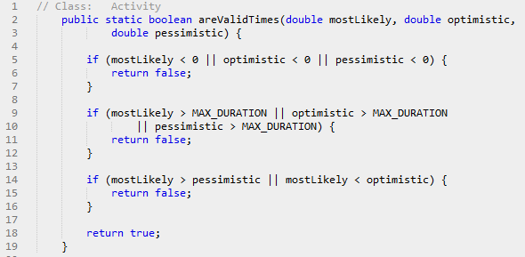
Figure 1: areValidTimes() - Code
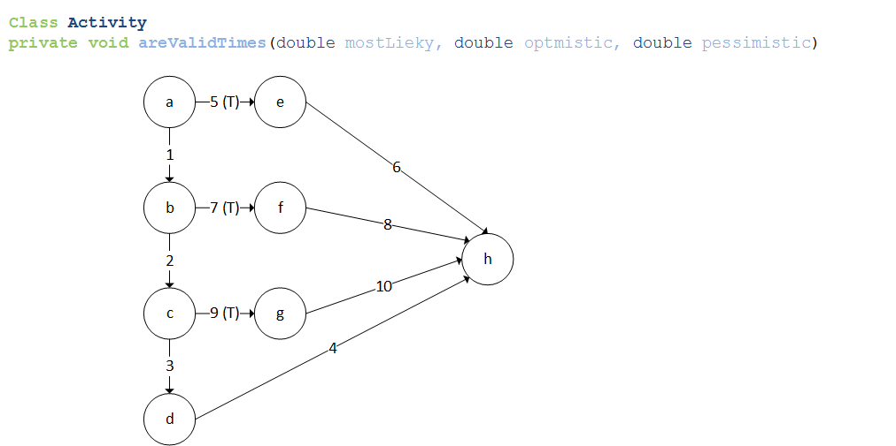
Figure 2: areValidTimes() - CFG

Cyclomatic-Complexity:

Complexity = num. Decision nodes + 1

= 3 + 1

= 4

Basis-Path Coverage:

Test Cases: {

1: <1,2,3,4>

2: <5,6>

3: <1,7,8>

5: <1,2,9>

}

Test 1 Input:

- node a: All inputs greater than 0

- node b: All inputs less than Activity.MAX_DURATION

- node c: most likely less than pessimistic and more than optimistic

Test 2 Input:

- node a: At least 1 input less than 0

Test 3 Input:

- node a: All inputs greater than 0

- node b: At east 1 input greater than Activity.MAX_DURATION

Test 4 Input:

- node a: All inputs greater than 0

- node b: All inputs less than Activity.MAX_DURATION

- node c: most likely greater than pessimistic or less than optimistic

2.2 MilestoneNode – equals()
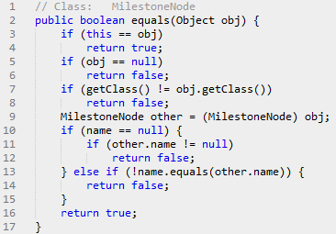
Figure 3: equals() - Code
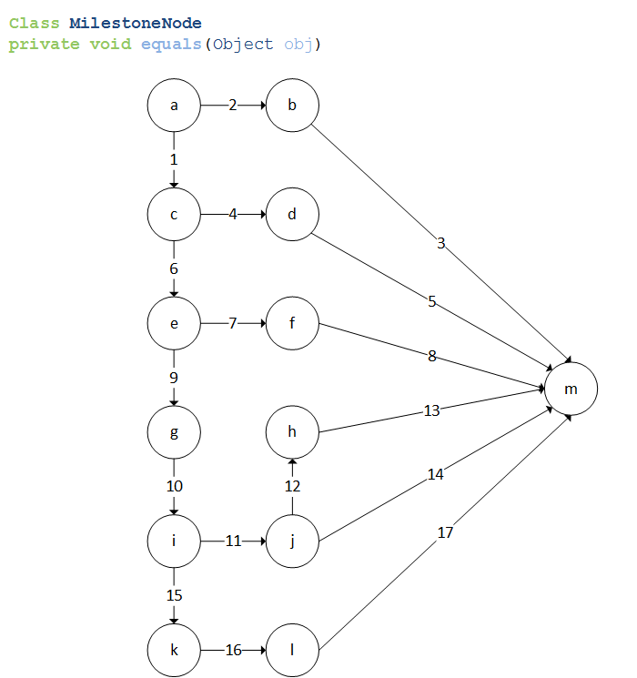
Figure 4: equals() - CFG

Cyclomatic-Complexity:

Complexity = num. Decision nodes + 1

= 6 + 1

= 7

Basis-Path Coverage:

Test Cases: {

1: <1,6,9,10,15,16,18,19>

2: <2,3>

3: <1,4,5>

4: <1,6,7,8>

5: <1,6,9,10,11,12,13>

6: <1,6,9,10,11,12,14>

7: <1,6,9,10,15,16,17>

}

Test 1 Input:

- node a: obj is NOT equal to calling MilestoneNode

- node c: obj is NOT null

- node e: obj class is of type MilestoneNode

- node i: Caller's name NOT null

- node l: obj name is same as calling MilestoneNode

Test 2 Input:

- node a: obj is equal to calling MilestoneNode

Test 3 Input:

- node a: obj is not equal to calling MilestoneNode

- node c: obj is null

Test 4 Input:

- node a: obj is not equal to calling MilestoneNode

- node c: obj is not null

- node e: obj class is NOT of type MilestoneNode

Test 5 Input:

- node a: obj is NOT equal to calling MilestoneNode

- node c: obj is NOT null

- node e: obj class is of type MilestoneNode

- node i: Caller's name is null

INFEASIBLE - Caller's name always initialized

(Note: our overridden version is meant to fully match the default version of the equals function. This is why verifying the Caller's name not equal null remains)

Test 6 Input:

- node a: obj is NOT equal to calling MilestoneNode

- node c: obj is NOT null

- node e: obj class is of type MilestoneNode

- node i: Caller's name is null

INFEASIBLE - Caller's name always initialized

Test 7 Input:

- node a: obj is NOT equal to calling MilestoneNode

- node c: obj is NOT null

- node e: obj class is of type MilestoneNode

- node i: Caller's name NOT null

- node l: obj name is NOT same as calling MilestoneNode

2.3 NodeGraph – addEdge()
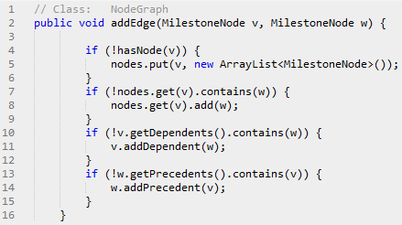
Figure 5: addEdge() - Code
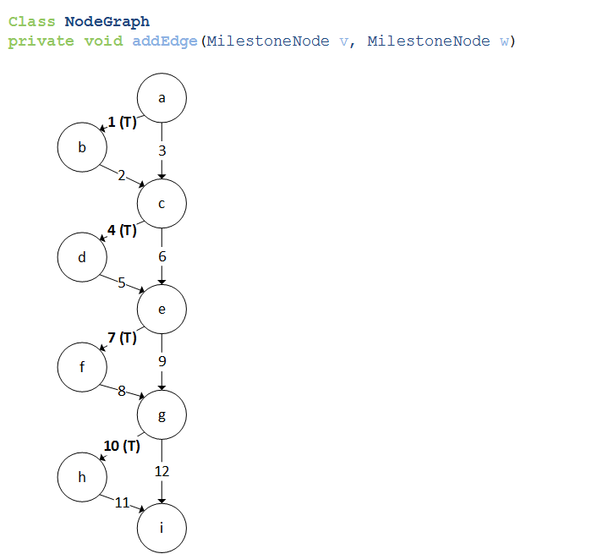
Figure 6: addEdge() - CFG

Cyclomatic-Complexity:

Complexity = num. Decision nodes + 1

= 4 + 1

= 5

Basis-Path Coverage:

Test Cases: {

1: <1,2,4,5,7,8,10,11>

2: <3,4,5,7,8,10,11>

3: <1,2,6,7,8,10,11>

4: <1,2,4,5,9,10,11>

5: <1,2,4,5,7,8,12>

}

Test 1 Input:

- node a: NodeGraph DOES NOT contain v

- node c: v DOES NOT contain w

- node e: w is NOT dependent on v

- node g: v is NOT a precedent of w

Test 2 Input:

- node a: Nodegraph contains v

- node c: v DOES NOT contain w

- node e: w is NOT dependent on v

- node g: v is NOT a precedent of w

Test 3 Input:

- node a: NodeGraph DOES NOT contain v

- node c: v contains w

INFEASIBLE – IF V NOT ALREADY IN NODE GRAPH, CANNOT CONTAIN W

(Note: We know this to be true as these are the first and only inputs to the NodeGraph)

Test 4 Input:

- node a: NodeGraph DOES NOT contain v

- node c: v DOES NOT contain w

- node e: w is dependent on v

- node g: v is NOT a precedent of w

INFEASIBLE – IF W DEPENDS ON V, V MUST BE PRECEDENT OF W

(Note: We know this to be true as these are the first and only inputs to the NodeGraph)

Test 5 Input:

- node a: NodeGraph DOES NOT contain v

- node c: v DOES NOT contain w

- node e: w is NOT dependent on v

- node g: v is a precedent of w

INFEASIBLE – IF W DOEST NOT DEPEND ON V, V CAN'T BE PRECEDENT OF W

2.4 EarnedValue – calculateActualCost()
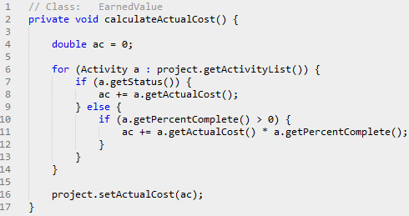
Figure 7: calculateActualCost() - Code
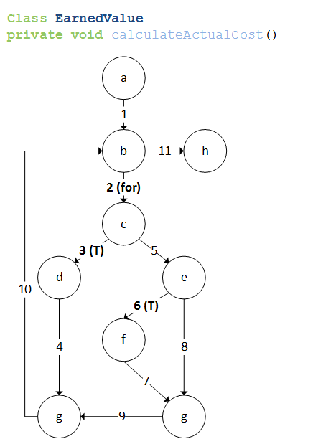
Figure 8: calculateActualCost() - CFG

Cyclomatic-Complexity:

Complexity = num. Decision nodes + 1

= 3 + 1

= 4

Basis-Path Coverage:

Test Cases: {

1: <1,2,3,4,10,11>

2: <1,11>

3: <1,2,5,6,7,9,10,11>

4: <1,2,5,8,9,10,11>

}

Test 1 Input:

- node b: Project(p) has ONE Activity(a)

- node c: a.status = true

Test 2 Input:

- node b: Project(p) has NO Activities

Test 3 Input:

- node b: Project(p) has ONE Activity(a)

- node c: a.status = false

- node e: a.percentComplete > 0

Test 4 Input:

- node b: Project(p) has ONE Activity(a)

- node c: a.status = false

- node e: a.percentComplete = 0

2.5 MilestoneNode – toStringArrows()
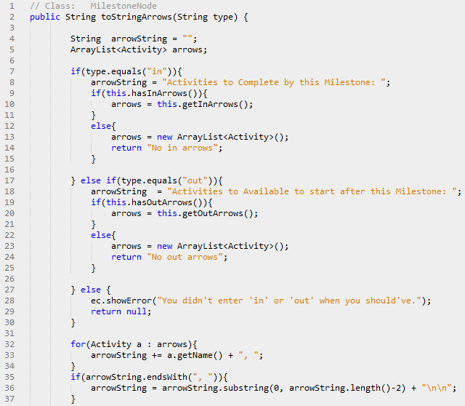
Figure 9: toStringArrows() - Code
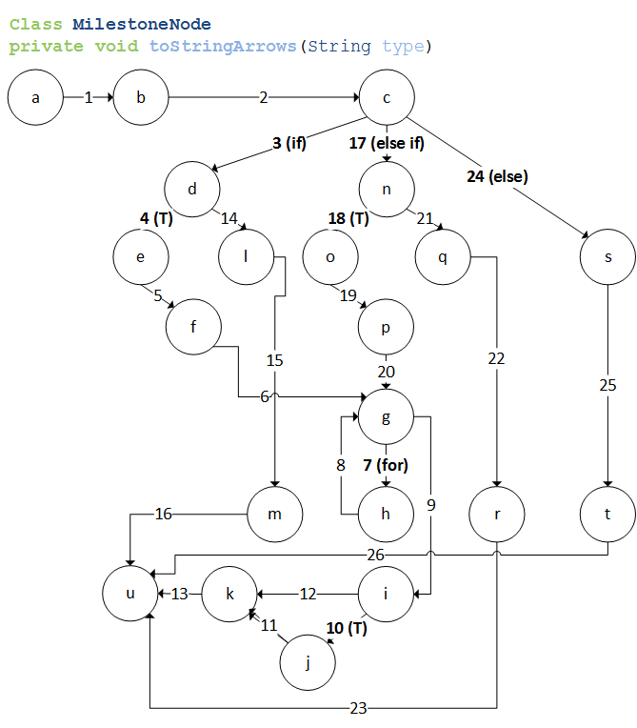
Figure 10: toStringArrows() - CFG

Cyclomatic-Complexity:

Complexity = num. Edges – num. nodes + 2

= 26 – 21 + 2

= 7

Basis-Path Coverage:

Test Cases: {

1: <1,2,3,4,5,6,7,8,9,10,11,13>

2: <1,2,3,4,14,16>

3: <1,2,3,4,5,6,9,10,11,13>

4: <1,2,3,4,5,6,7,8,9,12,13>

5: <1,2,17,18,19,20,7,8,9,10,11,13>

6: <1,2,17,21,22,23>

7: <1,2,24,25,26>

}

Test 1 Input:

- node c: type = "in"

- node d: MilestoneNode has ONE inArrow

- node g: MilestoneNode has ONE inArrow

- node i: arrowString ends with ", "

Test 2 Input:

- node c: type = "in"

- node d: MilestoneNode has NO inArrow

Test 3 Input:

- node c: type = "in"

- node d: MilestoneNode has ONE inArrow

- node g: MilestoneNode has NO inArrows

INFEASIBLE – CONTRADICTION IN NUMBER OF INARROWS

Test 4 Input:

- node c: type = "in"

- node d: MilestoneNode has ONE inArrow

- node g: MilestoneNode has ONE inArrow

- node i: arrowString DOES NOT end with ", "

INFEASIBLE – ARROWSTRING WILL ALWAYS END IN “,” WHEN ARROW EXISTS

Test 5 Input:

- node c: type = "out"

- node n: MilestoneNode has ONE outArrow

- node g: MilestoneNode has ONE outArrow

- node c: arrowString ends with ", "

Test 6 Input:

- node c: type = "out"

- node n: MilestoneNode has NO outArrows

Test 7 Input:

- node c: type not equal "in" or "out"

3.0 Black-Box Testing
Worst-case boundary-analysis testing requires that for each input variable we determine the 5 following values:
- min – the minimum value
- min+ – a value just above minimum
- nominal – that average value
- max- – slight below the maximum
- max – the maximum value

As worst-case analysis rejects the single-fault assumption, we must then test the function with every possible combination of the above . This results in 5^{n} tests to run (where n is the number of parameters to the function).

For each function, a table containing these 5 values for each parameter is provided. These inputs are based on the ranges specified in section 1.2. The tests must be run for each combination.

3.1 EarnedValue - getActivityScheduleValue()
Inputs:
Parameter | Min | Min+ | Nom | Max- | Max
ActivityEarlyFinish | 0.0 | 1.0 | 30.0 | 730.0 | 731.0
activityLateFinish | 0.0 | 1.0 | 30.0 | 730.0 | 731.0
activityPlannedVal | 0.0 | 1.0 | 30.0 | 730.0 | 731.0
activityDuration | 0.0 | 1.0 | 30.0 | 730.0 | 731.0
daysSinceStart | 0.0 | 1.0 | 30.0 | 730.0 | 731.0
Num. Tests : 5⁵ = 3125

3.2 Project - areValidPercentages()
Inputs:
Parameter | Min | Min+ | Nom | Max- | Max
Percentage1 | 0.0 | 0.01 | 0.5 | 0.99 | 1.0
Percentage2 | 0.0 | 0.01 | 0.5 | 0.99 | 1.0
Tests : 5² = 25

3.3 Project - areValideValues()
Inputs:
Parameter | Min | Min+ | Nom | Max- | Max
BudgetAtCompletion | 0.0 | 1.0 | 1000.0 | 9999999.0 | 10000000.0
ActualCost | 0.0 | 1.0 | 1000.0 | 9999999.0 | 10000000.0
EarnedValue | 0.0 | 1.0 | 1000.0 | 9999999.0 | 10000000.0
Tests : 5³ = 125

3.4 Activity - areValideValues()
Inputs:
Parameter | Min | Min+ | Nom | Max- | Max
MostLikely | 0.0 | 1.0 | 30.0 | 730.0 | 731.0
Optimistic | 0.0 | 1.0 | 30.0 | 730.0 | 731.0
Pessimistic | 0.0 | 1.0 | 30.0 | 730.0 | 731.0
Tests : 5³ = 125

3.5 Activity - areValidPercentAndCost()
Inputs:
Parameter | Min | Min+ | Nom | Max- | Max
PercentComplete | 0.0 | 0.01 | 0.5 | 0.99 | 1.0
ActualCost | 0.0 | 1.0 | 500000.0 | 999999.0 | 1000000.0
Tests : 5² = 25

4.0 Test Implementation & Headers
The implementations for each test and all it's test cases are provided in a separate package in out source code. Test Headers for each implemented test case is provided alongside its code. The information they include are:
- Identifier for test case
- Brief description
- Preconditions
- Inputs and expected outputs
- Expected post-conditions

These test-case headers are included in Appendix A for white-box tests, and Appendix B for black-box tests.

5.0 Discussion
Our experience with different testing mechanisms was very insightful, particularly in highlighting the differences for each method. Through our difficulty in finding functions suitable for both black-box and white-box testing, it became fully apparent that each method serves a different purpose.
White-box testing requires a full understanding of the code at hand, and becomes ideal when a function takes no inputs at all. Furthermore, it can also be useful when the input is not easily bounded, such as a complex data type with several instance variables. Thus white-box is ideal for testing the complex logic and algorithms for private helper-functions.
Black-box testing on the other hand allows algorithms to be ignored entirely. Validation derives from volume and range of inputs rather than through fewer, more specific inputs. For example, one of our test had 3125 test cases; contrasted to some of our white-box tests with only 2 cases, the difference is quite apparent. Thus the logic is tested not be going down each path, but by feeding enough varied input that we can assume the function is correct.
Ultimately, all our tests passed, which grants us a certain confidence that the functions are well-designed. Although we had no bug-fixing related to these function directly, the design of these tests did force us to questions certain design choices. For example, we have several functions with return statements embedded within the logic, which became quite difficult to trace, particularly when designing the inputs for our tests. In retrospect, we may have designed these functions differently.

6.0 A Note on Redesign
During this iteration, the development team really focused on separating the domain logic from the GUI. More specifically, a DisplayController class was added to communicate with the MainController. The goal was to ensure that no PModel object exists above the domain logic level (MainController), and that all GUI components (JComboBoxes and Lists) are generated by DisplayController via strings and integers which it requests from MainController. The mapping of GUI elements to the underlying objects is done in MainController, with minimal error checking in the GUI (such not accepting empty strings) and DisplayController (such as not accepting negative values).
A notable exception to this are the Analysis GUIs: GANTT, Pert, and Earned Value Analysis have access to the project that they are being generated upon. This is done primarily because they belong to the business logic level, and as such are not true GUI elements. Only their output gets displayed. The other reason is to avoid cumbersome and excessive argument passing.
MainController now coordianates with three helper objects which communicate with the database: a DataLoader, DataDeleter, and DataUpdater. This is done to increase some of the cohesion in MainController, as well as to alleviate its God class status. In the previous iteration document, we stated that we are not using a pure MVC design. In fact, we are not using the pattern at all; we are relying on message passing from GUI components (JFrames and JDialogs) to DisplayController, which in turn communicates with MainController, which delegates to the 3 data objects. If we were to redo the project all over, we would have implemented the pattern properly. However, given that a complete rewrite with our existing code base was out of the question, so we adapted as we could and learned a great deal in the process.

References:
Daniel Sinnig PhD: Lecture Slides, COMP 354

Appendix

Appendix A – White-Box Function Headers

NodeGraph - addEdge()

/**
* Function to test: NodeGraph::addEdge()
* Identifier: addEdge_whiteBoxPath_1
* Description: Test for basis-coverage path 1
* Preconditions:
* - NodeGraph DOES NOT contain v
* - v DOES NOT contain w
* - w is NOT dependent on v
* - v is NOT a precedent of w
* Inputs:
* - MilestoneNode v1, w1;
* Outputs:
* - void
* PostConditions:
* - NodeGraph contains v1
* - v1 is precedent of w1
* - w1 is dependent of v1
*/

/**
* Function to test: NodeGraph::addEdge()
* Identifier: addEdge_whiteBoxPath_2
* Description: Test for basis-coverage path 2
* Preconditions:
* - NodeGraph contains v
* - v DOES NOT contain w
* - w is NOT dependent on v
* - v is NOT a precedent of w
* Inputs:
* - MilestoneNode v2, w2, dummy;
* Outputs:
* - void
* PostConditions:
* - NodeGraph contains v2
* - v2 is precedent of w2
* - w2 is dependent of v2
*/

EarnedValue - calculateActualCost()
/**
* Function to test: EarnedValue::calculateActualCost()
* Identifier: calcActCost_whiteBoxPath_1
* Description: Test for basis-coverage path 1
* Preconditions:
* - Project(p) has ONE Activity(a)
* - a.status = true
* Inputs:
* - void
* Outputs:
* - void
* PostConditions:
* - Correct cost calculated
*/

/**
* Function to test: EarnedValue::calculateActualCost()
* Identifier: calcActCost_whiteBoxPath_2
* Description: Test for basis-coverage path 2
* Preconditions:
* - Project(p) has ONE Activity(a)
* - a.status = true
* Inputs:
* - void
* Outputs:
* - void
* PostConditions:
* - Correct cost calculated
*/

/**
* Function to test: EarnedValue::calculateActualCost()
* Identifier: calcActCost_whiteBoxPath_3
* Description: Test for basis-coverage path 3
* Preconditions:
* - Project(p) has ONE Activity(a)
* - a.status = false
* - a.percentComplete > 0
* Inputs:
* - void
* Outputs:
* - void
* PostConditions:
* - Correct cost calculated
*/

/**
* Function to test: EarnedValue::calculateActualCost()
* Identifier: calcActCost_whiteBoxPath_4
* Description: Test for basis-coverage path 4
* Preconditions:
* - Project(p) has ONE Activity(a)
* - a.status = false
* - a.percentComplete = 0
* Inputs:
* - void
* Outputs:
* - void
* PostConditions:
* - Correct cost calculated
*/

MilestoneNode - equals()
/**
* Function to test: MilestoneNode::equals()
* Identifier: equals_whiteBoxPath_1
* Description: Test for basis-coverage path 1
* Preconditions:
* - other is NOT equal to caller
* - other is NOT null
* - other class is of type MilestoneNode
* - caller name NOT null
* - other name is same as caller
* Inputs:
* - Object other;
* Outputs:
* - boolean
* PostConditions:
* - returns true
*/

/**
* Function to test: MilestoneNode::equals()
* Identifier: equals_whiteBoxPath_2
* Description: Test for basis-coverage path 2
* Preconditions:
* - other is equal to caller
* Inputs:
* - Object other;
* Outputs:
* - boolean
* PostConditions:
* - returns true
*/

/**
* Function to test: MilestoneNode::equals()
* Identifier: equals_whiteBoxPath_3
* Description: Test for basis-coverage path 3
* Preconditions:
* - other is NOT equal to caller
* - other is null
* Inputs:
* - Object other;
* Outputs:
* - boolean
* PostConditions:
* - returns false
*/

/**
* Function to test: MilestoneNode::equals()
* Identifier: equals_whiteBoxPath_4
* Description: Test for basis-coverage path 4
* Preconditions:
* - other is NOT equal to caller
* - other is NOT null
* - other class is NOT of type MilestoneNode
* Inputs:
* - Object other;
* Outputs:
* - boolean
* PostConditions:
* - returns false

/**
* Function to test: MilestoneNode::equals()
* Identifier: equals_whiteBoxPath_7
* Description: Test for basis-coverage path 7
* Preconditions:
* - other is NOT equal to caller
* - other is NOT null
* - other class is of type MilestoneNode
* - caller name NOT null
* - other name is NOT same as caller
* Inputs:
* - Object other;
* Outputs:
* - boolean
* PostConditions:
* - returns false
*/

}

MilestoneNode - toStringArrows()

/**
* Function to test: MilestoneNode::toStringArrows()
* Identifier: toStringArrows_whiteBoxPath_1
* Description: Test for basis-coverage path 1
* Preconditions:
* - type = "in"
* - MilestoneNode has ONE inArrow
* - MilestoneNode has ONE inArrow
* Inputs:
* - String type;
* Outputs:
* - void
* PostConditions:
* - outputs correct string
*/

/**
* Function to test: MilestoneNode::toStringArrows()
* Identifier: toStringArrows_whiteBoxPath_2
* Description: Test for basis-coverage path 2
* Preconditions:
* - type = "in"
* - MilestoneNode has NO inArrow
* Inputs:
* - String type;
* Outputs:
* - void
* PostConditions:
* - outputs correct string
*/

/**
* Function to test: MilestoneNode::toStringArrows()
* Identifier: toStringArrows_whiteBoxPath_5
* Description: Test for basis-coverage path 5
* Preconditions:
* - type = "in"
* - MilestoneNode has ONE inArrow
* - MilestoneNode has ONE inArrow
* Inputs:
* - String type;
* Outputs:
* - void
* PostConditions:
* - outputs correct string
*/

/**
* Function to test: MilestoneNode::toStringArrows()
* Identifier: toStringArrows_whiteBoxPath_6
* Description: Test for basis-coverage path 6
* Preconditions:
* - type = "out"
* - MilestoneNode has NO outArrows
* Inputs:
* - String type;
* Outputs:
* - void
* PostConditions:
* - outputs correct string
*/

/**
* Function to test: MilestoneNode::toStringArrows()
* Identifier: toStringArrows_whiteBoxPath_7
* Description: Test for basis-coverage path 7
* Preconditions:
* - type != "in" or "out"
* Inputs:
* - String type;
* Outputs:
* - void
* PostConditions:
* - outputs null
*/

MilestoneNode – equals()
/**
* Function to test: Activity::areValidTimes()
* Identifier: areValidTimes_whiteBoxPath_1
* Description: Test for basis-coverage path 1
* Preconditions:
* - All inputs greater than 0
* - All inputs less than Activity.MAX_DURATION
* - mostlikely less than pessimistic and more than optimistic
* Inputs:
* - double mostLikely, optimistic, pessimistic
* Outputs:
* - boolean
* PostConditions:
* - return true
*/

/**
* Function to test: Activity::areValidTimes()
* Identifier: areValidTimes_whiteBoxPath_2
* Description: Test for basis-coverage path 2
* Preconditions:
* - At least 1 input less than 0
* Inputs:
* - double mostLikely, optimistic, pessimistic
* Outputs:
* - boolean
* PostConditions:
* - return false
*/

/**
* Function to test: Activity::areValidTimes()
* Identifier: areValidTimes_whiteBoxPath_3
* Description: Test for basis-coverage path 3
* Preconditions:
* - All inputs greater than 0
* - At least 1 input greater than Activity.MAX_DURATION
* Inputs:
* - double mostLikely, optimistic, pessimistic
* Outputs:
* - boolean
* PostConditions:
* - return false
*/

/**
* Function to test: Activity::areValidTimes()
* Identifier: areValidTimes_whiteBoxPath_4
* Description: Test for basis-coverage path 4
* Preconditions:
* - All inputs greater than 0
* - All inputs less than Activity.MAX_DURATION
* - mostLikely greater than pessimistic or less than optimistic
* Inputs:
* - double mostLikely, optimistic, pessimistic
* Outputs:
* - boolean
* PostConditions:
* - return false
*/

Appendix B – Black-Box Function Headers

EarnedValue - getActivitySchedule()

/**
* Function to test: EarnedValue::getActivitySchedule()
* Identifier: getActivitySchedule_blackBox
* Description: Blackbox Test for getActivityScheduleValue()
* Inputs:
* - double earlyFinish, lateFinish, plannedValue, duration, daysSinceStart
* Outputs:
* - double scheduleValue
* PostConditions:
* - correct scheduleValue is returned
*/

Activity - areValidPercentAndCost()
/**
* Function to test: Activity::areValidPercentAndCost()
* Identifier: areValidPercentAndCost_blackBox
* Description: Blackbox Test for areValidPercentAndCost()
* Inputs:
* - double percent, cost
* Outputs:
* - boolean
* PostConditions:
* - return true
*/

Activity - areValidTimes()
/**
* Function to test: Activity::areValidTimes()
* Identifier: areValidTimes_blackBox
* Description: Blackbox Test for areValidTimes()
* Inputs:
* - double mostLikey, optimistic, pessimistic
* Outputs:
* - boolean
* PostConditions:
* - return true
*/

Project - areValidPercentages()
/**
* Function to test: Project::areValidPercentages()
* Identifier: areValidPercentages_blackBox
* Description: Blackbox Test for areValidPercentages()
* Inputs:
* - double percent1, percent2
* Outputs:
* - boolean
* PostConditions:
* - return true
*/

Project - areValidValues()

/**
* Function to test: Project::areValidValues()
* Identifier: areValidValues_blackBox
* Description: Blackbox Test for areValidValues()
* Inputs:
* - double value1, value2, value3
* Outputs:
* - boolean
* PostConditions:
* - return true
*/

